Test board Architecture and Implementation for neuron hardware accelerator engine

Tel Aviv University
Electrical Engineering Final Project 2024-2025

Version 0.6
13.05.2025

Yuval Desalto
Ariel Richter

Table of Contents

Overview 3
Theoretical Background 4
Requirements Definition 5
Performance Requirements 5
Validation Requirements 6
Top Block Diagram 8
Pre-Silicon Validation (FPGA-Based Testing – RTL Simulation) 9
Post-Silicon Validation (Fabricated DUT Testing – Real Hardware Validation) 9
Pre silicone 11
FPGA and DUT Integration Architecture 11
Components and Signals of FPGA-DUT integration 12
Signals and data transfer Between Subsystems 13
Data Bus Width and Multi-Cycle Transfers 14
Test environment 15
Test environment Components and Signals 16
Workflow of the Test Environment 18
Generator Diagram 20
Components and Signals of the Generator 20
Generator Workflow 21
Validator Diagram 22
Components and Signals of the Validator 22
Validator Workflow 23
DUT Block Diagram 24
DUT Components and Signals 24
DUT Workflow 27
MAC Diagram 29
Components and Workflow of MAC unit 29
MAC Workflow 30
System Workflow: End-to-End Testing Process 31
Step-by-Step Execution of the Testing Workflow 31
SDRAM Data Management and Host Communication 34
Managing Button Bounce in the Reset Mechanism 37
Methodology: 37
How This Solves the Problem? 38
Post silicone 39
Hardware Setup for Post-Silicon Validation 39
Pin Placement 39
The diagram below shows the final planned pin placement for the DUT 39
Pinout Description 40
System-Level Schematic: DUT Integration and Power Routing 40
Appendix 42

Overview
The test board architecture is a key component of the testing framework for the MAC core, which serves as the Device Under Test (DUT) in this project. This architecture is designed to enable functional validation, performance evaluation, and reliability testing of the DUT during the pre-silicon validation and initial hardware testing stages. It provides a structured and modular approach to managing data flow, control signals, and test scenarios to ensure the MAC core functions correctly under various conditions.
At the center of the architecture is the FPGA, which acts as the primary platform for running test cases and simulating real-world scenarios. The FPGA includes buffers for data input and output, comparators for result validation, and a control unit that manages the testing process. This design ensures proper data communication between the FPGA and the DUT while enabling precise control of test parameters.
The test board integrates with external controllers or PCs to provide additional computational resources and manage data logging and analysis. This integration enhances flexibility and scalability, allowing the architecture to support different testing stages and future system requirements.
The architecture is built with modularity in mind, allowing individual functional blocks to be developed, tested, and optimized independently. This ensures that the testing system remains adaptable and capable of meeting evolving project needs while maintaining the accuracy and efficiency necessary for validating advanced semiconductor devices.

Theoretical Background

Hardware testing systems (Test Boards) are a critical component in the development and verification of advanced chips, particularly in projects based on deep learning principles and neural networks. This project focuses on developing a dedicated Test Board for testing a computational accelerator (MAC Core) based on the perceptron model. Designing and building such a system requires a deep understanding of the perceptron structure, data processing methodologies, and FPGA-based hardware verification. FPGA (Field Programmable Gate Array) platforms are central to this process, serving as the primary testing environment. Their reconfigurable architecture allows for the implementation of custom test benches that manage data input, output, and real-time validation of the DUT. This hardware-based approach ensures precise timing analysis, real-time error detection, and the ability to test under hardware-specific conditions, offering significant advantages over traditional software simulations. By leveraging FPGA technology, the system enables comprehensive validation, ensuring early detection of functional and integration issues while supporting a reliable development process.
A key aspect of the computational accelerator being tested is its reliance on the perceptron model, a foundational concept in machine learning and neural networks. The perceptron’s role and functionality are explained below to provide context for the DUT’s operation.

The Perceptron Model
The perceptron is a foundational concept in machine learning, mimicking the behavior of a single neuron in a neural network. It operates by performing a linear combination of input values, weighted by their respective coefficients, and adding a bias term. Mathematically, this can be expressed as:
$$y=\sum_{i=1}^{n}{w_{i}∙x_{i}+b}$$
where $w_{i}$ are the weights, $x_{i}$ are the inputs, and b is the bias term.
The perceptron’s output is determined by an activation function, which applies a threshold to the result of the linear summation. The function is defined as:
$$y= \left\{\begin{aligned}1 ;if y≥Threshold \\ 0 ; otherwise \end{aligned}\right.$$
In this project, the perceptron serves as the central computational unit within the MAC Core. Its purpose is to process input data efficiently, producing binary outputs that indicate whether certain conditions are met, such as recognizing patterns or calculating results in line with predefined thresholds.

Requirements Definition
The Test Board is designed to validate the functionality and performance of the computational accelerator (MAC Core), serving as the Device Under Test (DUT). The system requirements are defined to ensure reliable operation, compatibility with the FPGA platform, and the ability to achieve high testing coverage with minimal latency. These requirements encompass functional, performance, and validation metrics, ensuring the system meets the demands of pre-silicon and hardware-based testing stages.

Performance Requirements
- Clock Frequency:
The Test Board must operate at a clock frequency of 50 MHz. This frequency was selected based on the DE10-Lite FPGA’s operational specifications, ensuring compatibility with the clock management resources and the overall timing constraints of the board. The DE10-Lite supports clock frequencies within this range while maintaining stable and reliable operation. Operating at this frequency ensures that the design meets the timing requirements for accurate data processing and synchronization with the Device Under Test (DUT). This value was specifically chosen to optimize performance while ensuring the stability and reliability of the system under typical operating conditions.
- FPGA Resource Utilization:
The Test Board must limit its utilization to 50% of the FPGA’s available logic resources. This limitation was established to ensure that sufficient headroom remains for future development, debugging, or modifications that may arise as the project progresses. The DE10-Lite FPGA, equipped with 50,000 Logic Elements (LEs), is designed to accommodate designs of moderate complexity. By capping the utilization at 50%, we can prevent potential routing congestion and maintain timing stability across the design. This conservative allocation also ensures that any unforeseen requirements or features can be integrated into the system without requiring significant rework or impacting the system's performance.
- Power Consumption:
The Test Board must operate with a power consumption limit of 5W. This value was determined based on the specific usage capabilities of the DE10-Lite FPGA for our implementation. According to the DE10-Lite user manual, the power delivery system of the board is capable of reliably supplying this level of power, which includes both static (idle) and dynamic (operational) power consumption. By adhering to this limit, we ensure that the FPGA operates within its thermal and electrical constraints, avoiding overheating or power delivery issues. Additionally, maintaining this power limit aligns with efficient energy use and ensures that the board can support stable, long-term operation under typical conditions for our project requirements.
These requirements were carefully defined to balance the FPGA’s capabilities with the needs of the project, providing a robust foundation for current functionality while allowing room for future development.

Validation Requirements
To ensure the correctness and reliability of the DUT, the validation process is divided into three key phases: pre-silicon simulation, pre-silicon RTL prototyping, and post-silicon validation. Each phase targets different aspects of verification, from logical correctness to real-world system behavior. Additionally, real-time error reporting is an essential feature that supports debugging and validation across all stages but is not considered a separate validation phase.

Pre-Silicon Simulation

Pre-silicon simulation is the first stage of validation, where the DUT is tested in a software-based simulation environment. This phase focuses on verifying the logical correctness of the DUT before synthesis. Functional simulations are conducted at the RTL level to ensure that the DUT behaves as expected under different input scenarios. This process allows early detection of logical errors, misalignment with specifications, and potential inefficiencies in the design.

Pre-Silicon RTL Prototyping
To bridge the gap between simulation and real hardware testing, FPGA-based prototyping is used at the RTL level. The Test Board must enable the DUT to run on an FPGA platform, allowing for more accurate performance analysis, early debugging, and testing under real-world conditions. Unlike simulations, FPGA-based validation allows the design to run in actual hardware, exposing potential timing-related issues, memory access conflicts, and interface mismatches that may not appear in purely software-based simulations.

Post-Silicon Validation
Once the DUT has been fabricated or integrated into the FPGA platform, post-silicon validation is performed. This stage involves real-time functional and performance testing to identify any remaining issues that were not detected in pre-silicon phases. The system must support extensive real-time testing, including stress testing, functional corner cases, and hardware/software co-validation. The goal is to ensure that the implemented hardware meets all design specifications and operates correctly under realistic conditions.

Error Reporting (Applicable Across All Phases)

Error reporting is a fundamental aspect of the validation process. it plays a supporting role across pre-silicon simulation, RTL prototyping, and post-silicon validation. The Test Board must provide a robust real-time error detection and reporting mechanism, capturing details such as failed test cases, timing violations, and output mismatches. The error reporting system should be capable of detecting both transient and persistent errors, allowing efficiently trace back to root causes.

Flexibility and Scalability
The Test Board must support updates to the test environment, including modifications to test scenarios, additional DUT components, and changes in input/output configurations. This ensures adaptability to evolving project requirements and future scalability.

Top Block Diagram

The top block diagram represents the overall architecture of the project, structured into two distinct testing phases: pre-silicon validation and post-silicon validation. These phases ensure a comprehensive verification process, starting from RTL-level simulations to final hardware validation. The system integrates an FPGA-based test environment, an external DUT board for post-silicon testing, and a PC/controller, allowing for seamless data communication and evaluation of the MAC core at different development stages. This architecture provides a flexible and scalable testing framework, enabling precise debugging, performance analysis, and functionality verification across both stages.
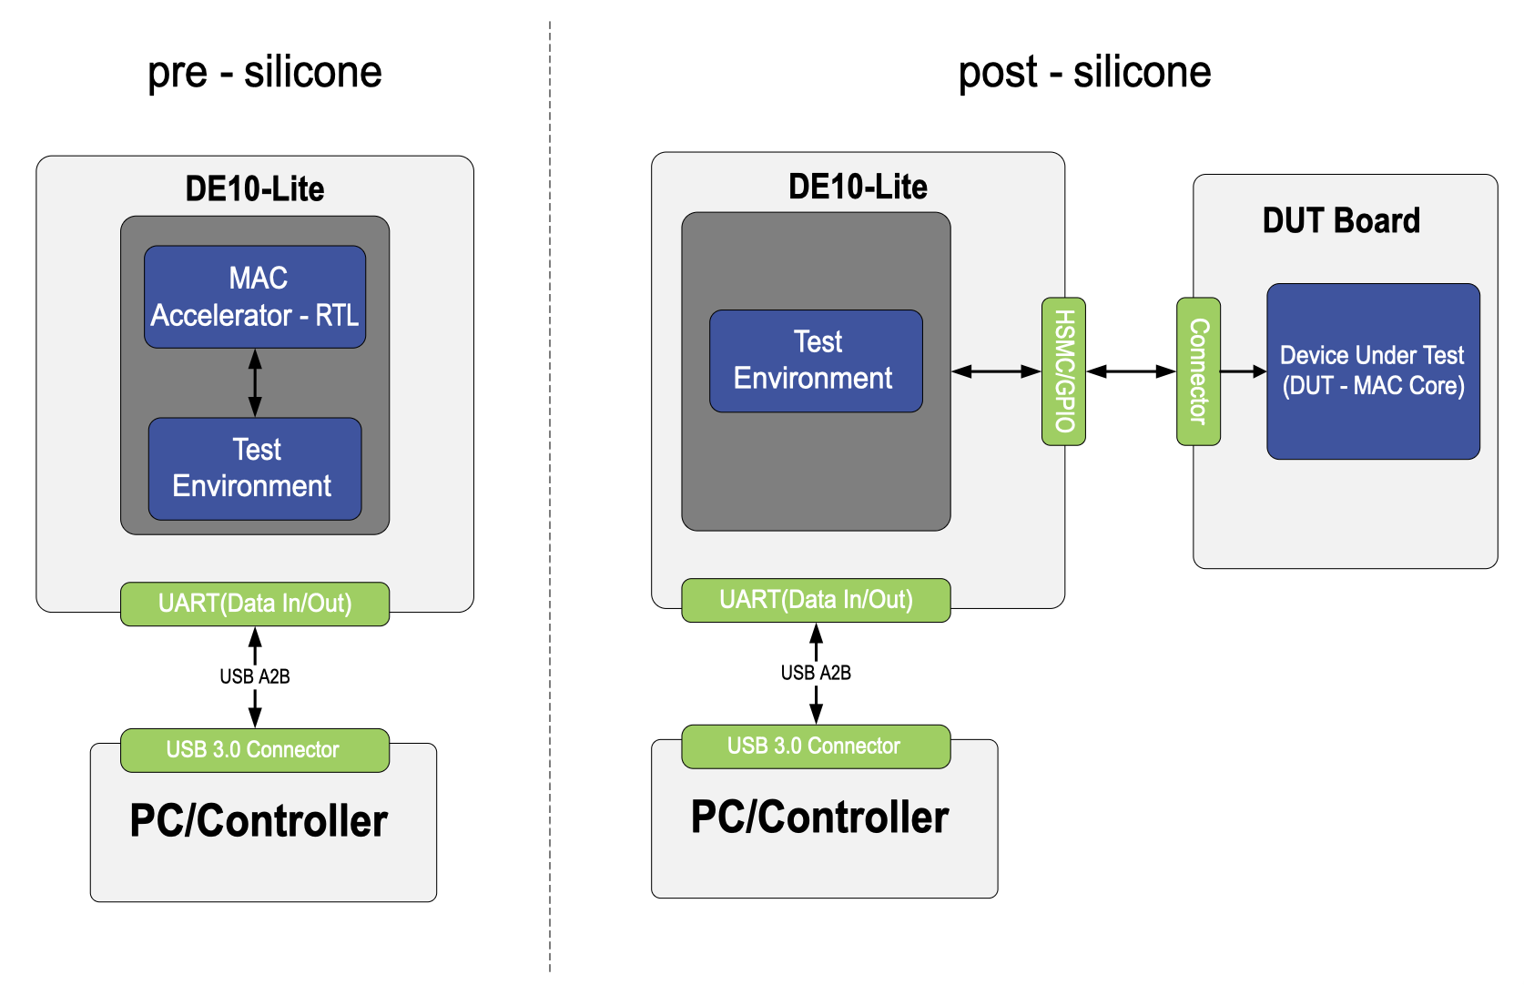
Figure 1 – Pre silicone and Post silicone Top Block Diagrams

Pre-Silicon Validation (FPGA-Based Testing – RTL Simulation)
During the pre-silicon phase, the MAC core is tested using an FPGA-based prototype before fabrication. This stage focuses on RTL verification and functional testing.
- The MAC core (RTL) is synthesized and implemented inside the DE10-Lite FPGA, along with the test environment.
- The test environment is responsible for generating input stimuli, handling execution, and validating outputs within the FPGA.
- Data is transferred between the PC/controller and FPGA via a UART interface, allowing test execution and real-time debugging.
- The PC/controller manages test execution, sending test vectors and analyzing results to ensure correctness before hardware fabrication.
- This stage helps identify logical errors, performance bottlenecks, and design flaws in a fully controlled simulation environment.

Post-Silicon Validation (Fabricated DUT Testing – Real Hardware Validation)
Once the MAC core has been fabricated into a physical chip, testing transitions to the post-silicon phase. This phase ensures that the real hardware implementation operates as expected under real-world conditions. Unlike pre-silicon testing, the MAC core is no longer inside the FPGA but instead exists on a separate DUT board, requiring external validation.
- The DE10-Lite FPGA now functions as a test environment, generating test stimuli and validating outputs received from the fabricated MAC core on the DUT board.
- The DUT board contains the fabricated MAC core, which processes the test inputs and produces outputs for verification.
- Data transfer between the FPGA and DUT board occurs through an HSMC/GPIO connector, ensuring correct signal exchange between the test system and the DUT.
- The PC/controller remains the central management unit, retrieving results from the FPGA and analyzing the DUT's performance.
- This stage helps identify hardware-related issues, fabrication defects, timing mismatches, and integration challenges that may not have been detected during pre-silicon simulation.

PC/Controller
- Acts as the central control unit for managing and monitoring both pre-silicon and post-silicon testing processes.
- In pre-silicon testing, it sends test vectors to the FPGA and receives simulation results for analysis.
- In post-silicon testing, it retrieves test results from the DUT through the FPGA.
- Provides an interface for test configuration, execution, and real-time debugging.
- Uses USB 3.0 for high-speed data transfer between the PC and FPGA.

Interfaces
- UART (Data In/Out) – FPGA to PC
  - Enables bidirectional communication between the FPGA and the PC/controller.
  - Used in both pre-silicon and post-silicon testing for logging test results and sending control signals.
- HSMC/GPIO Connector – FPGA to DUT Board
  - Handles data exchange between the FPGA test environment and the DUT.
  - Ensures proper transmission of test vectors and retrieval of processed results.
  - The exact connector type will depend on the final DUT board selection.

Pre silicone

FPGA and DUT Integration Architecture

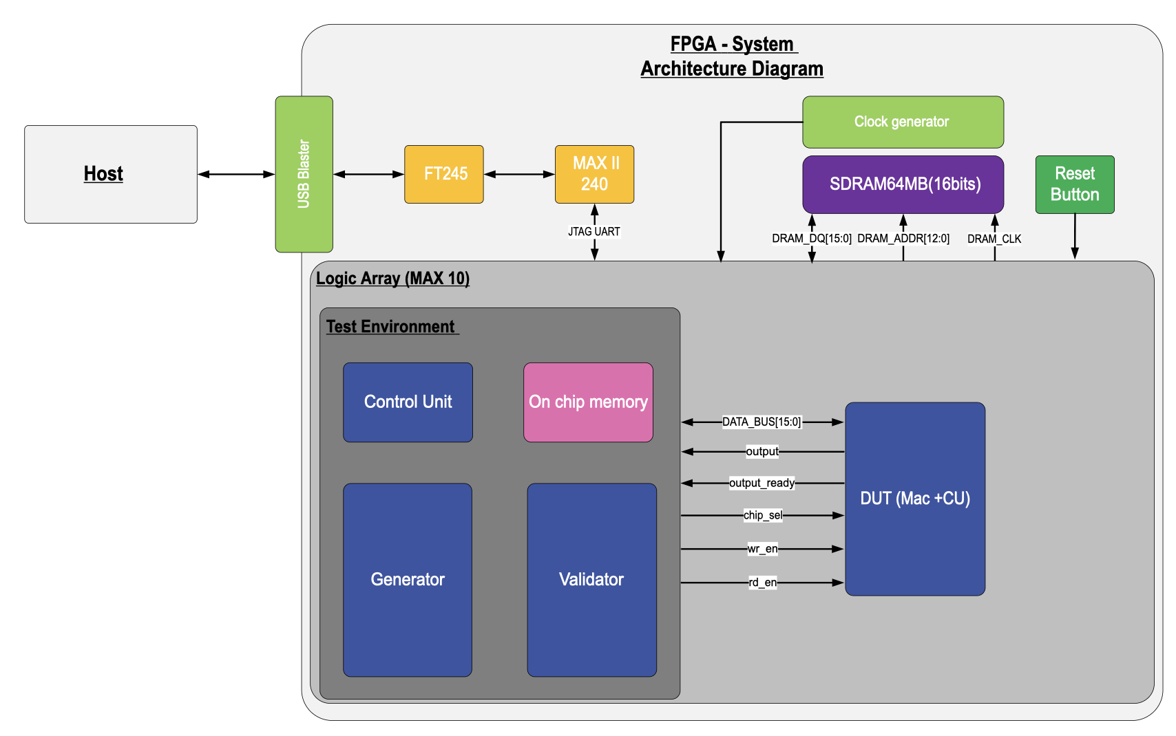
The system architecture is based on an FPGA and integrates various components to create a comprehensive testing environment and ensure overall functionality. At its core, the architecture includes a host computer that communicates with the system via a USB Blaster interface, enabling efficient data transfer and FPGA programming. A communication pathway is established using the FT245 component, which converts USB signals to UART, and the MAX II CPLD, which manages UART communication and supports JTAG access. The system is equipped with 64MB SDRAM for temporary data storage, interfaced via a 16-bit data bus and address lines, ensuring smooth data handling. A clock generator provides synchronized clock signals to drive the entire system, ensuring timing consistency across all components. The FPGA, based on a MAX 10 logic array, hosts the primary testing environment, which includes control, on chip memory, data generation, and validation units, along with the Device Under Test (DUT). This architecture supports robust testing, validation, and data management in a scalable and flexible manner.
Figure 2 - FPGA and DUT architecture

Components and Signals of FPGA-DUT integration

Host
The Host represents the external computer or controller used to communicate with the FPGA-based system. It sends commands, configurations, and data to the system via a USB Blaster interface.

USB Blaster
The USB Blaster serves as a bridge between the host computer and the FPGA system. It enables data transfer and programming of the FPGA through a USB interface.

FT245

The FT245 is a USB to UART bridge that converts USB signals into UART protocol. It facilitates efficient data flow between the host and the internal system, serving as a key component in communication.

MAX II (240)

The MAX II CPLD serves as a bridge between the UART interface and the system, managing communication and signal flow. It supports both UART and JTAG protocols for programming and debugging the FPGA.

Clock Generator

The clock generator provides the necessary clock signals to synchronize the operations of the system. It generates the DRAM_CLK signal, which is critical for operating the SDRAM and ensuring proper data transfer timing.

SDRAM (64MB, 16 bits)
The system includes a 64MB SDRAM module for temporary data storage during operations. It connects to the FPGA via several key signals:
- DRAM_DQ[15:0]: A 16-bit bidirectional data bus for transferring data.
- DRAM_ADDR[12:0]: An address bus used to specify memory locations for read and write operations.
- DRAM_CLK: A clock signal that ensures synchronized SDRAM operations.

Logic Array (MAX 10)
The MAX 10 FPGA is the main programmable logic component in the system, hosting key subsystems:
- Test Environment:
  - Control unit: Manages the testing process, controls the flow of operations, and oversees communication with the DUT.
  - Generator: Produces input signals or test patterns for evaluating the DUT.
  - Validator: Validates the outputs of the DUT by comparing them with expected results.
  - On chip memory: 64-Kbyte memory that is implemented inside the FPGA.
- Device Under Test (DUT):
  - Includes a MAC core and its associated control unit.
  - Acts as the primary system under evaluation within the test environment.

Reset Button
The Reset Button is a physical button located on the board, designed to reset the entire system. When pressed, the button triggers a reset signal that propagates through all components of the architecture. This signal initializes the system by clearing all internal states, memory contents, and control signals, returning the system to its default state. After the reset operation is complete, the system begins its initialization phase, during which data is loaded from the SDRAM into the on-chip memory to prepare for subsequent computations.
The reset functionality ensures that:
- All components, including the Control Unit, Generator, Validator, On-Chip Memory, and SDRAM Controller, are reinitialized.
- Data buses and internal counters are reset to prevent residual data from affecting the next computation cycle.
- The system clock and synchronization signals are realigned for proper operation after reset.
This button provides a convenient and reliable way to restart the system during development, debugging, or unexpected errors.

Signals and data transfer Between Subsystems
- DATA_BUS[15:0]: A 16-bit bidirectional bus used for data exchange between the test environment and the DUT.
- output: Carries the processed output data from the DUT to the test environment.
- output_ready: Indicates that the DUT has completed processing, and its output is ready for validation.
- chip_sel: Activates or enables the DUT during operations.
- wr_en: A write enable signal that initiates write operations within the DUT.
- rd_en: A read enable signal that initiates read operations from the DUT.
This diagram outlines a highly organized architecture where the host interfaces with the FPGA system via a USB link, data flows seamlessly through the various components, and the logic array performs testing and validation of the DUT with high precision.

Data Bus Width and Multi-Cycle Transfers
The system utilizes a 16-bit wide data bus, a design decision made to optimize resource efficiency since the majority of operations involve transferring 16-bit data. However, for operations requiring 22-bit data, such as loading the threshold value and reading the MAC unit output, data transfers are conducted over two consecutive clock cycles.
During write operations:
- In the first clock cycle, bits 0–15 are written to the target destination.
- In the second clock cycle, bits 16–22 are written, ensuring complete data transfer.
During read operations:
- In the first clock cycle, bits 0–15 are retrieved from the source.
- In the second clock cycle, bits 16–22 are read and padded with zeros on the left to maintain a consistent 16-bit width for compatibility with the system’s data path.
This two-cycle approach efficiently supports operations requiring 22-bit data while aligning with the design decision to use a 16-bit data bus. The choice of a 16-bit bus was made because the majority of system operations inherently involve transferring 16-bit data, making this width optimal for resource utilization and performance. While certain operations, such as threshold loading and MAC output reading, require handling 22-bit data, the two-cycle transfer mechanism ensures compatibility without compromising the system’s overall efficiency.

Test environment
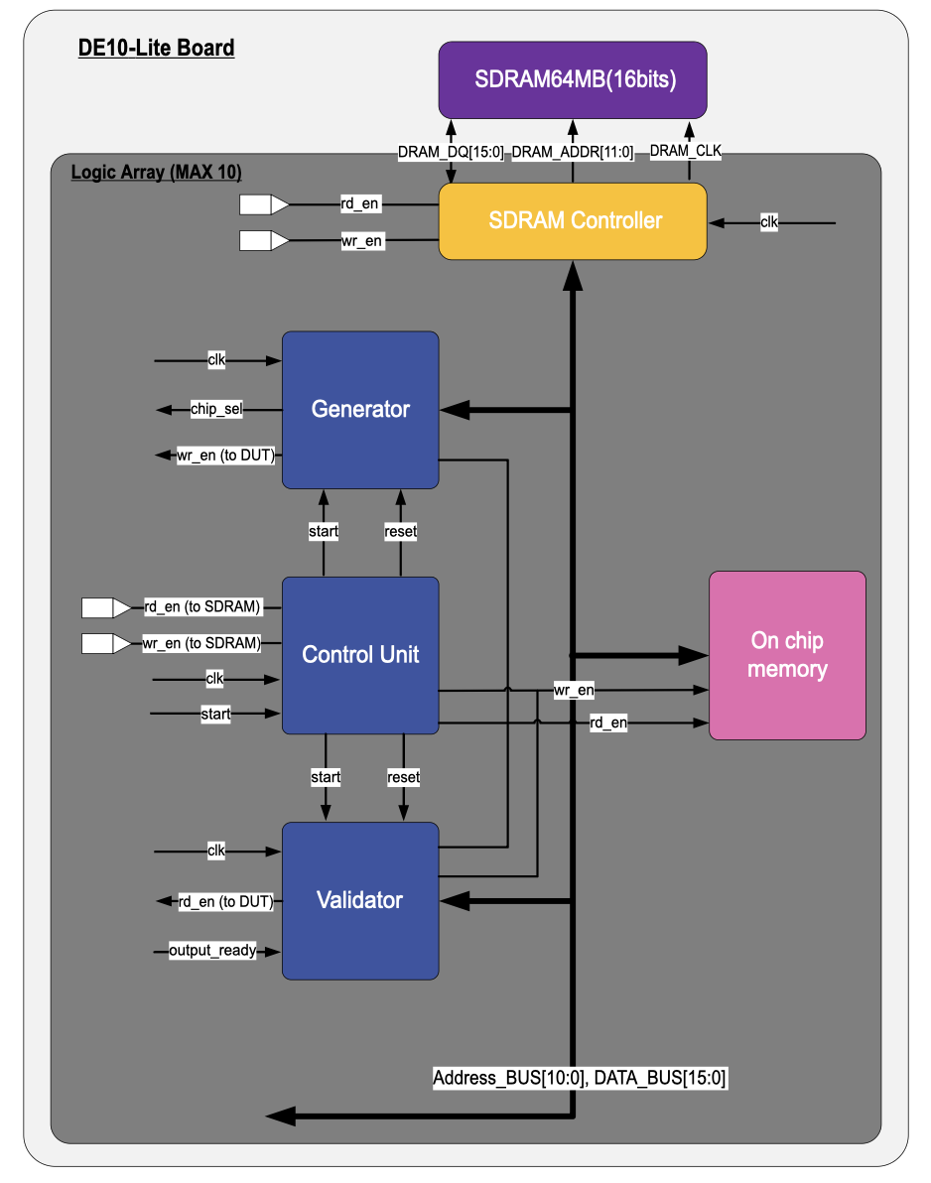
The test environment is designed to facilitate a controlled and efficient validation process for the DUT by generating test data, managing memory operations, and validating the DUT's outputs. It consists of key components, including the generator, validator, on-chip memory, and SDRAM controller, all managed by a central control unit. The test environment ensures accurate data flow, synchronization, and processing to validate the DUT's functionality against expected outputs.
Figure 3 – Test environment Diagram

Test environment Components and Signals

1. Control Unit
The control unit serves as the central coordinator for the test environment. It manages data flow, synchronization, and signal generation across all components, ensuring correct sequencing of operations.
Signals and data:
- Inputs:
  - start: Triggers the start of a new test cycle.
  - clk: Synchronizes the operations across the test environment.
  - reset_n: Reset signal from pushbutton.
- Outputs:
  - mem_address[10:0]: Specifies the memory address for read/write operations in the on chip memory.
  - wr_en: Enables writing data to the on-chip memory or SDRAM.
  - rd_en: Enables reading data from the on-chip memory or SDRAM.
  - start_run: Triggers operations in the generator.

2. Generator
The generator produces test data and manages its flow into the DUT. It reads input data from the on-chip memory and sends it to the DUT along with control signals.
Signals and data:
- Inputs:
  - DATA_BUS[15:0]: Transfers test data to the DUT.
  - clk: Synchronizes the generator’s operations with the control unit.
  - reset: Resets the generator’s internal states.
  - start: Initiates data generation.
- Outputs:
  - DATA_BUS[15:0]: Transfers test data from on chip memory to the DUT.
  - chip_sel: Selects the appropriate chip for data transfer (also responsible for resetting the chip components when chip_sel goes from low to high).
  - wr_en: Enables writing test data to the DUT.
  - address[10:0]: Memory address for reading test data.
  - Rd_en: enables reading data from on chip memory.

3. Validator
The validator compares the DUT's outputs with expected results stored in memory. It ensures the DUT's functionality by signaling success or failure based on the comparison.
Signals and data:
- Inputs:
  - clk: Synchronizes the validator’s operations with the control unit.
  - DATA_BUS[15:0]: Transfers DUT outputs and expected data from on chip memory to the validator.
  - reset: Resets the Validator’s internal states.
  - start: Triggers the comparison process.
  - output_ready: Indicates that the DUT finished its calculation.
- Outputs:
  - Wr_en: enables writing validation data to on chip memory.
  - Rd_en: enables reading expected data from on chip memory.
  - Rd_en: enables reading data from DUT.
  - Address: address for reading expected outputs from on chip memory.
  - DATA_BUS[15:0]: Transfers validation results (MAC_comp and output_comp) to on chip memory.

4. On-Chip Memory
The on-chip memory acts as a buffer for storing test data, expected outputs, and intermediate results. It operates in close coordination with the control unit, ensuring low-latency data access during testing.
Signals and data:
- Inputs:
  - address[10:0]: Specifies the memory location for read/write operations.
  - wr_en: Enables writing data to memory.
  - rd_en: Enables reading data from memory.
  - DATA_BUS[15:0]: Transfers data from SDRAM memory.
  - clk: Synchronizes memory operations.
- Outputs:
  - DATA_BUS[15:0]: Provides data to the DUT and validator.
  - DATA_BUS[15:0]: Transfers data to SDRAM memory.

5. SDRAM Controller and SDRAM
The SDRAM controller manages the SDRAM, which serves as an external memory for storing large datasets. It ensures proper timing and synchronization for data transfer between the SDRAM and other components in the test environment.
Signals and data:
- Inputs:
  - wr_en: Enables writing data to SDRAM.
  - rd_en: Enables reading data from SDRAM.
  - clk: Synchronizes SDRAM operations.
  - DRAM_DQ[15:0]: Transfers data to/from SDRAM.
  - DATA_BUS[15:0]: Provides data to the on-chip memory.
- Outputs:
  - DATA_BUS[15:0]: Provides data to the on-chip memory, generator, or validator.
  - DRAM_ADDR[11:0]: Specifies SDRAM addresses for read/write operations
  - DRAM_CLK: provides clock for the SDRAM.
  - DRAM_DQ[15:0]: Transfers data to/from SDRAM.

Workflow of the Test Environment

1. Initialization Phase
- The control unit asserts the reset signal to initialize all components, including the generator, validator, on-chip memory, and SDRAM controller. This clears any previous data or states.
- Input data (pixel-weight pairs and expected results) are loaded into the on-chip memory from SDRAM . The IO block facilitates this transfer via the DATA_BUS[15:0] with the control unit managing the process using wr_en and address signals.

2. Data Generation Phase
- The control unit issues a start signal to the generator, initiating the data retrieval process.
- The generator fetches pixel-weight pairs sequentially from the on-chip memory using the rd_en and address[10:0] signals.
- Data retrieved from memory is sent to the DUT through the DATA_BUS[31:0], along with control signals such as chip_sel and wr_en to ensure correct data routing and timing.

3. Processing Phase
- The DUT processes the incoming data. The MAC unit performs element-wise multiplication of pixels and weights, accumulates the results, and sends the cumulative output to the activation function.
- During this phase, the inner DUT control unit coordinates the operation of the DUT, ensuring that each component (e.g., MAC, activation function) is activated at the correct time.
- Intermediate results are monitored, and data integrity is verified through internal checks within the DUT.

4. Validation Phase
- The control unit issues a start signal to the validator, initiating the validation process.
- The validator retrieves the expected results from the on-chip memory via the DATA_BUS[15:0] using the rd_en and address[10:0] signals.
- The DUT’s output is compared against the expected results in real time. The validator generates comparison signals (output_comp and MAC_comp) to indicate whether the outputs match the expected values.
- If a mismatch is detected, the validator flags the error, and the results are stored for debugging.

5. Output Storage Phase
- Once the comparison process is complete, the validated output data is written back to the on-chip memory which than proceeds to the SDRAM and from there to the host (pc). The control unit manages this operation using wr_en and address[10:0].
- The output_ready signal is asserted by the validator to indicate that the final results are available for retrieval.

6. Idle Phase
- After completing the validation and data retrieval processes, the control unit transitions the system to an idle state.
- All components remain in a ready state, awaiting the next start signal to begin a new computation cycle.

Generator Diagram

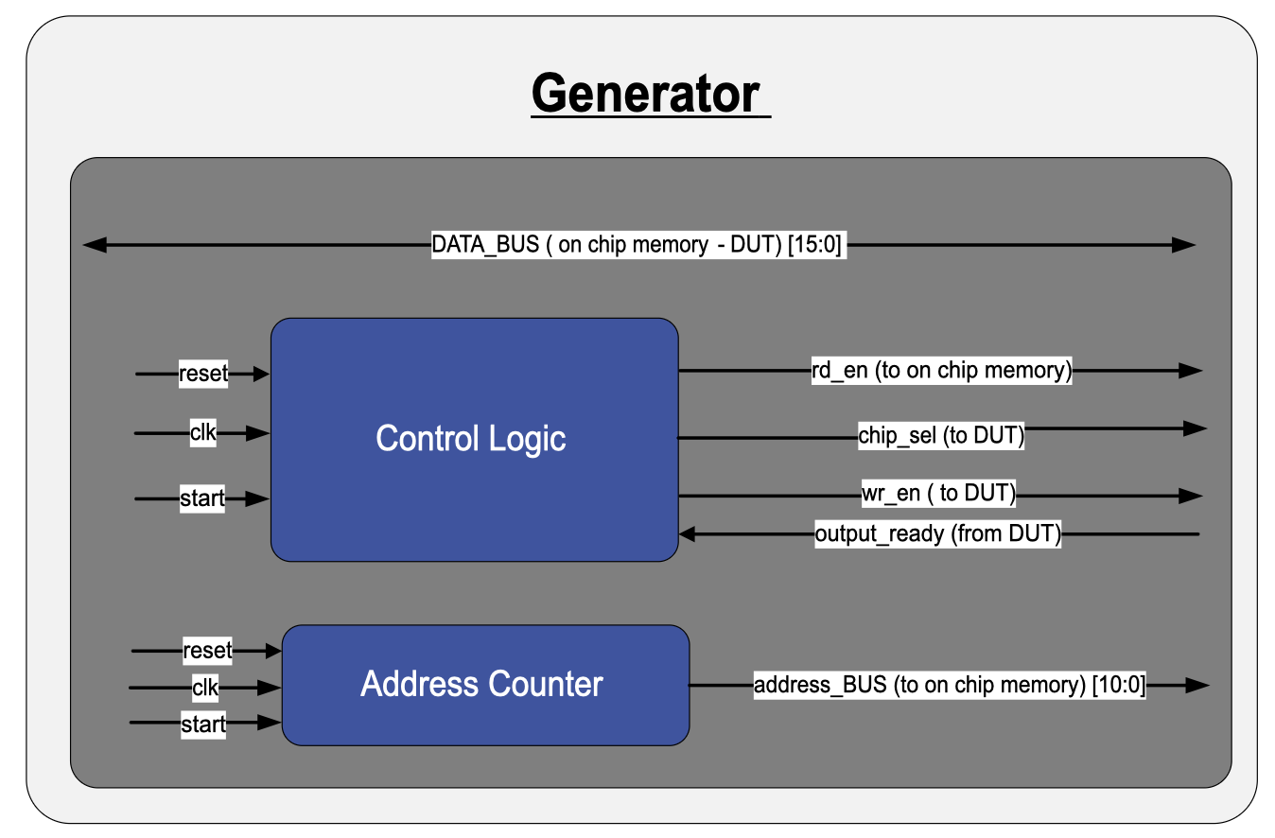
The generator serves as a crucial component in the FPGA-based testing environment, responsible for managing the retrieval of data from the on chip memory and delivering it to the Device Under Test (DUT). Its primary function is to coordinate the data flow by generating addresses and control signals required for memory access, ensuring accurate and timely delivery of data to the DUT for processing. The generator operates in synchronization with the system clock and responds to commands from the control unit to initiate data transfers.
Figure 4 - Generator Diagram

Components and Signals of the Generator

Components:
- Control Logic
  - Manages the overall operation of the generator.
  - Sends control signals to both the on chip memory and the DUT to ensure correct data transfer.
  - Responsible for asserting the required signals to the DUT, such as wr_en and chip_sel to enable data movement.
- Address Counter
  - Generates memory addresses for reading data from the on chip memory.
  - Advances the address based on the clock and start signal to retrieve the next set of data.
  - Works in conjunction with the control logic to provide precise address values to the on chip memory.

Signals and data

Inputs:
- reset: Resets the generator to its initial state, clearing counters and control signals.
- clk: The clock signal used to synchronize the generator's operations with the system.
- start: A signal from the control unit that initiates the data transfer process.
- output_ready: received from DUT to give feedback about the duration of time that chip_sel needs to stay high.

Outputs:
- address_BUS[10:0]: Sent to the on chip memory by the address counter to specify the memory location for data retrieval.
- DATA_BUS[15:0]: A bidirectional bus used to transfer data between the on chip memory and the DUT.
- rd_en: Read enable signal to access data from the on chip memory.
- chip_sel: Chip select signal to enable the DUT for receiving data (needs to stay high until one cycle after output_ready is received).
- wr_en: Write enable signal to load the retrieved data into the DUT.

Generator Workflow

Upon receiving a start signal, the generator initiates the data transfer process. The address counter generates a new memory address and sends it to the on chip memory to specify the location of the data to be read. Simultaneously, the control logic issues a rd_en (read enable) signal to the on chip memory, instructing it to retrieve the requested data. The retrieved data is then transmitted through the DATA_BUS to the DUT. Along with the data, the control logic sends the necessary control signals, such as chip_sel and wr_en, to the DUT, enabling it to begin processing the incoming data. This coordinated process ensures accurate data delivery and proper synchronization between the on chip memory generator, and DUT.

Validator Diagram

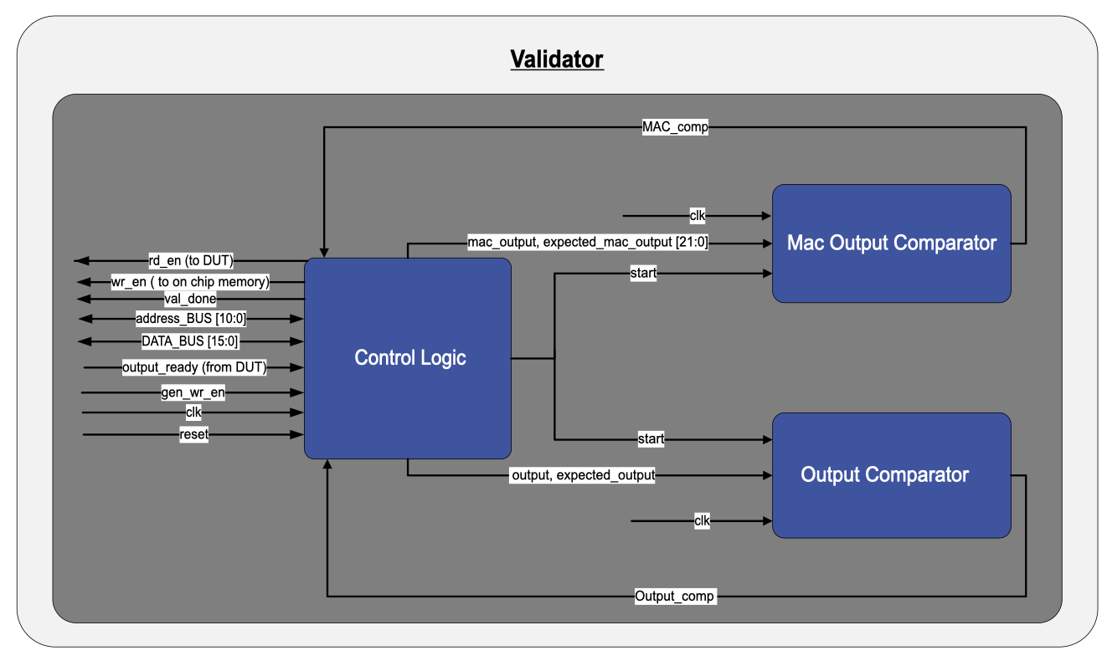
The validator is a critical component in the testing environment, responsible for ensuring the correctness of the DUT's operations. It achieves this by comparing the outputs generated by the DUT with the expected results stored in memory. The validator operates in real-time, analyzing the results and signaling completion or errors when discrepancies are found. This ensures that the system can identify and validate the proper functionality of the DUT efficiently and reliably.
Figure 5 - Validator Diagram

Components and Signals of the Validator

Components-
- Control Logic
  - Orchestrates the validation process by managing the flow of data and signals within the validator.
  - Monitors the data from the DUT, the on chip memory, and coordinates the start of comparison processes.
  - Sends control signals such as start to the comparator units and handles the done signal once the validation is complete.
- MAC Output Comparator
  - Compares the MAC operation outputs from the DUT with expected results retrieved from the memory.
  - If discrepancies are found, it flags them by sending the comparison results back to memory using the MAC_comp signal through the data bus.
- Output Comparator
  - Compares the final output data from the DUT with the expected results fetched from the in chip memory.
  - Sends validation results back to memory using the Output_comp signal through the data bus.

Signals and data-

Inputs:
- reset: Resets the validator, clearing all internal states in the control logic.
- clk: Synchronizes the operations of the validator with the system clock.
- output_ready: Indicates that the DUT has finished processing, and its output is available for validation.
- output: The data output from the DUT that needs to be validated.
- expected_output: The pre-stored expected results fetched from memory for comparison.
- gen_wr_en: write enable sent to the DUT from Generator. used in the validator to count when all the required data finished transfer to the DUT and the validation process can start.
- DATA_BUS[15:0]: Transfers data between the DUT outputs and the expected results stored in the on chip memory to the validator.

Outputs:
- wr_en: Enables writing the comparison results into memory.
- rd_en: Read enable signal to access data from the DUT.
- Address_BUS[10:0]: Sent to the on chip memory to specify the memory location for data retrieval.
- DATA_BUS[15:0]: Transfers the MAC_comp and output_comp signals to the on chip memory.

Validator Workflow
The validation process begins when the output_ready signal from the DUT is received. The control logic initiates the validation by activating the start signal for both comparator units. The MAC Output Comparator compares the intermediate MAC results from the DUT with the expected results stored in memory, indicating a match/mismatch using the MAC_comp signal. Concurrently, the Output Comparator validates the final outputs from the DUT against the expected results retrieved from the on chip memory, recording discrepancies via the Output_comp signal. Once all comparisons are completed, the control logic asserts the done signal, signaling the end of the validation process.

DUT Block Diagram

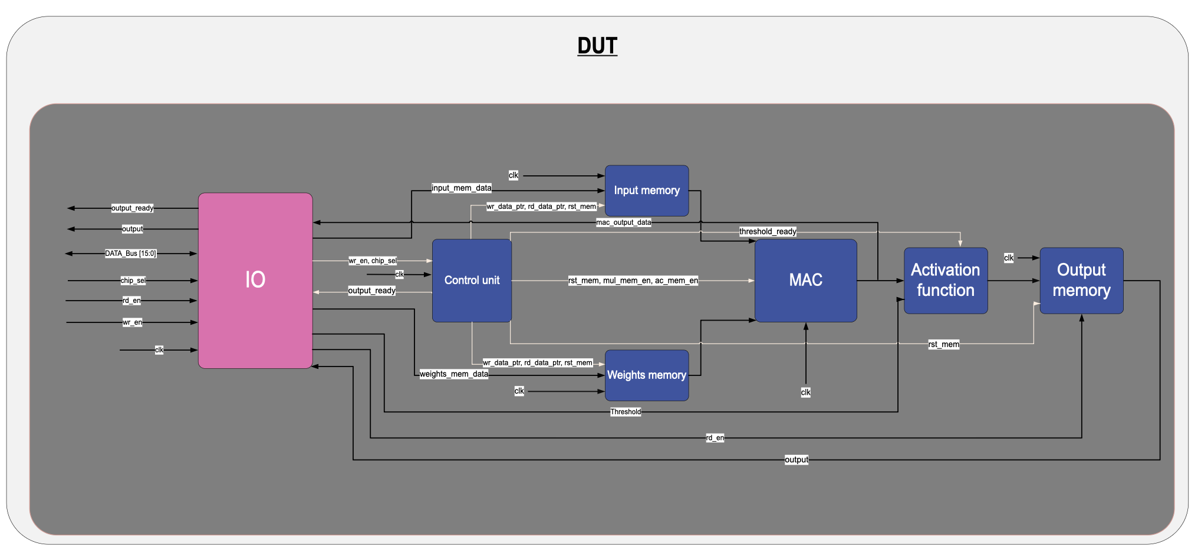
This diagram illustrates the internal architecture of the DUT, which is designed to process pixel-weight pairs and produce final outputs for validation. The DUT integrates an IO block, control unit, input and weights memory blocks, a MAC unit, an activation function, and an output memory block. Each component operates in synchronization, with the control unit orchestrating data flow and processing across the pipeline.
Figure 6 - DUT diagram

DUT Components and Signals

1. IO Block
The IO block serves as the main interface for data transfer between external systems and the DUT. It facilitates initialization by receiving pixel, weight, and threshold data, and provides real-time access to intermediate results and final outputs. The IO block ensures seamless communication with the DUT's internal components.
Signals and data:
- Inputs:
  - DATA_BUS[15:0]: Transfers input data (pixels, weights, and thresholds) from external systems to the DUT.
  - wr_en: Enables writing input data into the DUT’s memory.
  - rd_en: Enables reading data from output memory for external systems.
  - chip_sel: Selects specific components or memory blocks for data transfer.
- Outputs:
  - output: Provides the processed final results to external systems.
  - output_ready: Indicates the completion of the DUT's processing pipeline and readiness of output data.
  - DATA_BUS[15:0]: Transfers output data (mac_output_data) from DUT to external system.

2. Control Unit
The control unit coordinates the operation of all subsystems within the DUT, including memory access, MAC unit activation, and threshold application in the activation function. It generates control signals to manage data flow and ensures that each component operates in proper synchronization.
Signals and data:
- Inputs:
  - clk: Synchronizes the DUT's operations.
  - wr_en: Enables writing input data into the DUT’s memory.
  - chip_sel: Selects specific components or memory blocks for data transfer.
- Outputs:
  - wr_data_ptr: Specifies the address in memory for data writing.
  - rd_data_ptr: Specifies the address in memory for data reading.
  - mul_mem_en: Activates the MAC unit’s multiplication operation.
  - ac_mem_en: Enables the MAC unit’s accumulator to store intermediate results.
  - rst_mem: Resets the Output Memory, and Accumulator to their initial states before computation begins.
  - threshold_ready: Indicates readiness to sample and apply the threshold value.
  - output_ready: Signals that the DUT has finished processing.

3. Input Memory
The input memory stores pixel data received during initialization. During computation, it supplies pixel data to the MAC unit for processing.
Signals and data:
- Inputs:
  - wr_data_ptr: Specifies the memory address for writing pixel data.
  - rd_data_ptr: Specifies the memory address for reading pixel data during computation.
  - clk: Synchronizes memory operations.
  - rst_mem: Clears the memory contents before starting a new computation.

4. Weights Memory
The weights memory stores the weight values corresponding to the input pixels. These weights are retrieved during computation for processing by the MAC unit.
Input Signals:
  - wr_data_ptr: Specifies the memory address for writing weight data.
  - rd_data_ptr: Specifies the memory address for reading weight data during computation.
  - clk: Synchronizes memory operations.
  - rst_mem: Resets the memory contents before a new computation cycle.

5. MAC (Multiply-Accumulate) Unit
The MAC unit performs the core arithmetic operations, multiplying pixel data with weight values and accumulating the results. It operates under the control of the control unit and passes its final output to the activation function.
Signals and data:
- Inputs:
  - Pixel data: Received from the input memory.
  - Weight data: Received from the weights memory.
  - mul_mem_en: Enables the multiplication operation.
  - ac_mem_en: Enables the accumulation operation.
  - clk: Synchronizes the MAC operations with the system.
  - rst_mem: Resets the accumulator before starting a new computation.
- Outputs:
  - mac_output_data: The accumulated result sent to the activation function.

6. Activation Function
The activation function applies a threshold to the accumulated result from the MAC unit, generating a binary output.
Signals and data:
- Inputs:
  - MAC_output: Data from the MAC unit to be processed.
  - threshold_ready: Indicates that the threshold value is ready to be applied.
  - threshold: The predefined threshold value used for comparison.
- Outputs:
  - Processed data: Sent to the output memory for storage.

7. Output Memory
The output memory stores the processed data from the activation function. It serves as a buffer, allowing the IO block to retrieve results for external validation or further processing.
Signals and data:
- Inputs:
  - Data: Received from the activation function.
  - rst_mem: Resets memory for new computations.
  - clk: Synchronizes memory operations with the DUT.
  - rd_en: Enables reading data for external systems.
- Outputs:
  - output: Sent to the IO block for external retrieval.

DUT Workflow
- Initialization Phase
  - The FSM within the control unit manages the initialization by orchestrating memory write operations.
  - Pixel data and weight values are transferred from the IO block to the input memory and weights memory using the wr_data_ptr signal.
  - The threshold value is also received from the IO block and stored in the threshold register within the activation function.
  - The rst_mem signal is asserted to reset all internal memories and prepare the system for a new computation cycle.
- Data Fetch Phase
  - The control unit issues the rd_data_ptr signal to sequentially read pixel data from the input memory and weight values from the weights memory.
  - The data is fed into the MAC unit in the correct order for computation, ensuring alignment between the pixel and weight pairs.
- Processing Phase
  - The MAC unit performs element-wise multiplication of pixel and weight pairs using its multiplier.
  - The results are zero-padded and passed to the accumulator via the adder to calculate a cumulative sum.
  - The control unit generates the mul_mem_en and ac_mem_en signals to enable the multiplication and accumulation processes, ensuring proper synchronization of operations.
- Thresholding Phase
  - After all pixel-weight pairs have been processed, the cumulative result from the MAC unit is sent to the activation function.
  - The threshold_ready signal is asserted, enabling the threshold register within the activation function to sample the threshold value from the data bus during the final cycle of computation.
  - The activation function compares the accumulated result with the stored threshold value and generates a binary output (1 or 0) based on whether the result meets or exceeds the threshold.
- Output Storage Phase
  - The binary output from the activation function is written to the output memory under the control of the FSM using the wr_en signal.
  - The output memory stores the final results, making them available for retrieval by external systems.
- Result Retrieval Phase
  - Once the computation is complete, the output_ready signal is asserted, signaling that the final processed results are available.
  - The IO block retrieves the output data from the output memory and sends it to external systems for validation or further use.
- Idle Phase
  - After all computations are completed and the results are retrieved, the control unit transitions the DUT into an idle state, preparing the system for the next operation cycle.

MAC Diagram

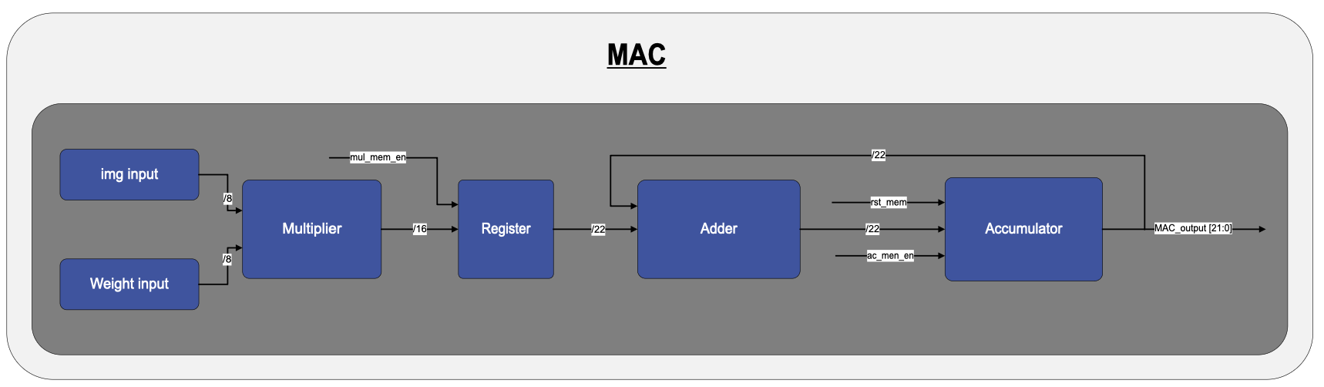
The MAC (Multiply-Accumulate) unit is a fundamental component within the DUT, responsible for executing the arithmetic operations required for processing pixel-weight pairs. This unit performs element-wise multiplication followed by accumulation of the results, which are then passed to subsequent processing stages. The MAC unit operates in a synchronized manner, ensuring that intermediate results are retained across multiple cycles, allowing for efficient and precise calculations.
Figure 7 - MAC diagram

Components and Workflow of MAC unit

Components:
- Multiplier
  - Receives input pixel and weight values, performing element-wise multiplication.
  - Outputs a 16-bit result, which is forwarded to the next stage.
- Register
  - Temporarily holds the multiplication result produced by the multiplier.
  - Facilitates stable data flow to the adder, synchronized with the system clock.
  - Applies zero-padding to the 16-bit multiplication result to match the 22-bit format required by the subsequent stages.
- Adder
  - Receives the multiplication result from the register and adds it to the current accumulated value from the accumulator.
  - Produces a 22-bit summation result for the accumulation stage.
- Accumulator
  - Stores the intermediate and final summation results.
  - Provides the current accumulated value to the adder for continuous summation.
  - Outputs the final accumulated result as a 22-bit value.

Control Signals
- mul_mem_en
  - Enables the register to store the multiplier’s output.
  - Ensures that the multiplication result is sampled and held for addition.
- ac_mem_en
  - Enables the accumulator to sample and store the intermediate summation result.
  - Facilitates the continuous accumulation process by updating the stored value after each addition.
- rst_mem
  - Resets the accumulator to its initial state, clearing any previous summation results.

MAC Workflow
- At the start of the computation cycle, the MAC unit receives pixel and weight values through the img input and Weight input ports.
- The multiplier performs element-wise multiplication of the inputs, generating a 16-bit result.
- The multiplication result is stored in the register, which stabilizes the data for the next computation step.
- The adder receives the multiplication result and adds it to the accumulated sum retrieved from the accumulator.
- The updated summation is stored in the accumulator, ensuring the retention of intermediate results across cycles.
- Once all pixel-weight pairs are processed, the final accumulated result is made available at the MAC_output port for further processing.

Output
The MAC unit generates a 22-bit accumulated result, which is made available at the MAC_output port. This result can be utilized for further stages, such as activation or threshold comparison. The real-time accessibility of the output also allows for monitoring and debugging during the computation process.
This structured and efficient workflow ensures precise processing of pixel-weight pairs and robust arithmetic operations within the DUT.

System Workflow: End-to-End Testing Process
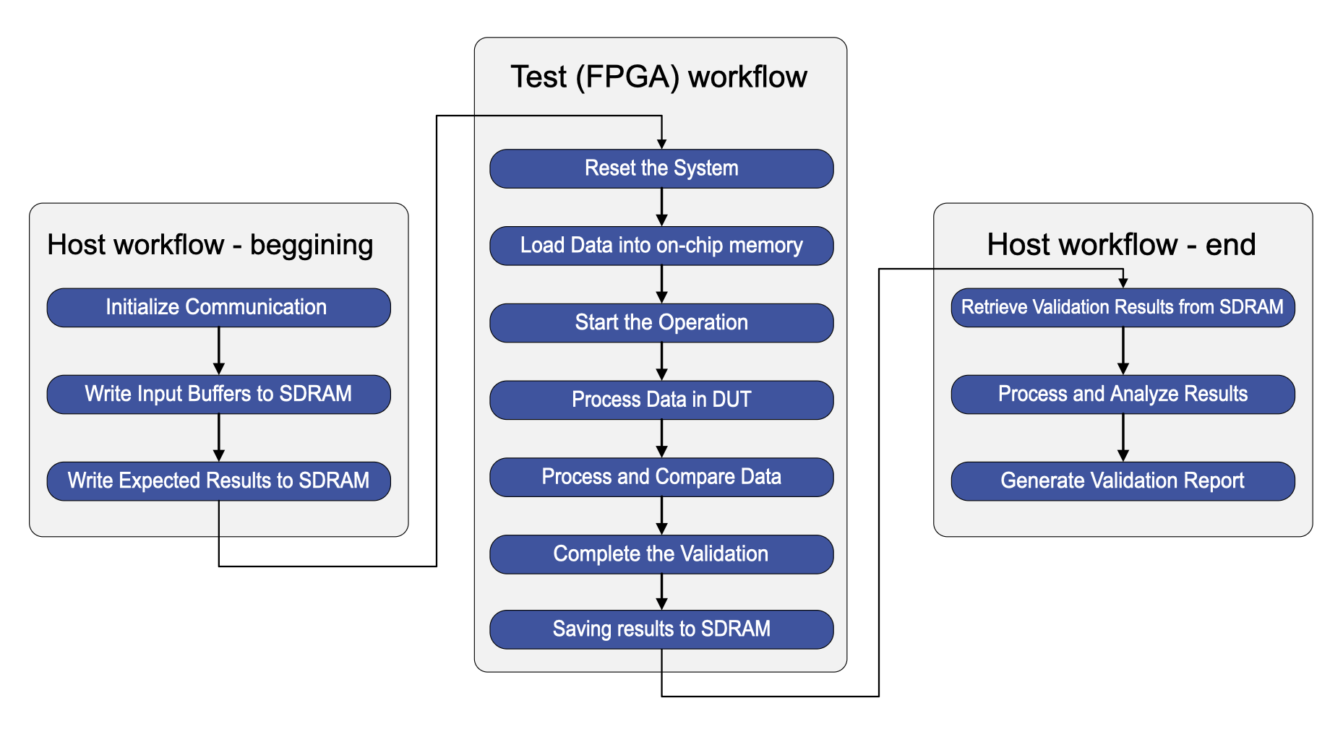
The system is designed to validate the DUT by executing predefined test cases, comparing the DUT's outputs against expected results, and reporting any mismatches. The testing process is fully automated, starting from data preparation on the host system and ending with the analysis of validation results. The workflow consists of several key stages to ensure efficient and accurate testing of the DUT.
Figure 8 – Full workflow diagram

Step-by-Step Execution of the Testing Workflow

1. Test Preparation on the Host (PC)
- The host system generates test inputs using Python scripts. These include pixel-weight pairs for computation, threshold values for activation, and expected results for validation.
- The generated test data is formatted and written to SDRAM, ensuring all necessary inputs are available for execution.
- The expected results are also stored in SDRAM, aligned with their corresponding test cases for later validation.

2. System Initialization
- The reset button on the FPGA board is pressed, triggering a reset signal that ensures all components, including the control unit, generator, validator, DUT, and memory, start from a known state.
- The control unit initiates data loading, fetching test inputs and expected results from SDRAM into the on-chip memory for faster access during test execution.

3. Test Execution
- The control unit signals the generator to begin the test.
- The generator retrieves test data from on-chip memory and sends them to the DUT via the data bus.
- The DUT processes the inputs, performing MAC operations and applying the activation function to generate an output.
- Once a test case is processed, the DUT sends its outputs to the validator for comparison.

4. Validation Process
- The validator receives the DUT’s computed results and compares them against the expected values retrieved from memory.
- Two main comparisons are performed:
  - MAC output comparison verifies if the intermediate results from the MAC unit match the expected intermediate results.
  - Final output comparison checks if the DUT’s processed results match the expected final outputs.
- For each test case, the validator generates a two-bit pass/fail indicator:
  - Bit 1 is 1 if the MAC result matches, 0 if it does not.
  - Bit 2 is 1 if the final output matches, 0 if it does not.
- These results are stored in the on-chip memory, along with the DUT’s actual outputs.

5. Result Storage and Retrieval
- Once all test cases have been executed, the pass/fail results and DUT outputs are transferred from on-chip memory to SDRAM.
- The host retrieves the validation results from SDRAM and processes them using Python scripts.

6. Error Reporting and Analysis
- The host system analyzes the validation results and generates a detailed test report, which includes the total number of test cases executed, a pass/fail summary indicating which tests succeeded and which failed, and a detailed breakdown of failed tests specifying whether the failure occurred at the MAC computation level or final output level.
- The report also highlights the exact differences between expected and actual results for debugging purposes.
- The test report provides valuable feedback to the DUT development team, helping them identify potential design flaws or incorrect computations in the DUT.

7. System Reset and Next Test Cycle
- After completing a test and storing the results, the system transitions to an idle state, awaiting further instructions from the host.
- If additional tests are needed, the system resets and repeats the workflow from system initialization to ensure a fresh start for each test batch.

SDRAM Data Management and Host Communication

1. Host Process Workflow
The host is responsible for preparing and transferring test files to the FPGA via the Control Panel software, as well as retrieving processed results. The process follows these steps:
- Test File Preparation:
  - The host generates a structured test file containing input matrices, weight values, threshold values, and expected results.
  - The file format aligns with the SDRAM memory structure for efficient data processing.
- Data Transfer to SDRAM:
  - Using the Control Panel software, the host writes multiple test cases sequentially into SDRAM.
  - Each test case occupies 140 bytes in SDRAM, where most of the space is allocated for input data, and only 2 bits represent the test environment computed result.
- Test Execution on FPGA:
  - The FPGA first transfers test cases from SDRAM to the on-chip memory, which acts as an intermediate buffer.
  - The on-chip memory holds the data relevant to the current test case, selected from the full set of test cases loaded into SDRAM, allowing faster access during processing.
  - Test cases are loaded into on-chip memory, ensuring a continuous execution flow without needing direct access from SDRAM during processing. Once a test is processed, a new test is loaded from SDRAM into on-chip memory, allowing efficient memory utilization.
  - From the on-chip memory, test data is distributed to the relevant components within the test environment for execution.
  - After processing, the computed 2-bit result is stored back in the on chip memory and from there to the SDRAM at a predefined location.
- Retrieving Results and Processing:
  - The host reads only the 2-bit test results, keeping the original test inputs in memory.
  - A validation script compares the retrieved results with expected values and generates a pass/fail report highlighting any discrepancies.

2. SDRAM Data Structure
The memory is organized to store test cases efficiently:
- The very first 16-bit word at address 0 contains the total number of test cases.
- Starting from address 1, the memory stores a sequence of test blocks, each representing a single test case.
- The FPGA control unit uses read and write pointers to sequentially access and update data, ensuring continuous processing.
- Each SDRAM test block contains:
  - A 16-bit header (0xABCD) identifying the start of the block
  - 68 fixed 16-bit data words containing:
    - Input matrices and weight values (64 words)
    - Threshold values (2 words)
    - Expected results (2 words) - the expected MAC output is represented as a 22-bit value, split across two 16-bit words:
      - First word (lower 16 bits): contains bits [15:0] of the expected MAC result.
      - Second word (upper 6 bits + 1-bit binary result):
        - Bits [5:0]: contain bits [21:16] of the MAC result.
        - Bit [6]: stores the expected binary classification result (0 or 1).
        - Bits [15:7]: set to 0.
The first word in the SDRAM contains the total number of test blocks.
SDRAM Memory Layout
Word Index | Contents | Description
0 | TEST_COUNT | Number of test blocks in SDRAM
1 + N*69 | HEADER (0xABCD) | Start of test block N
2 + N*69 to 69 + N*69 - 2 | DATA[0] to DATA[67] | - DATA[0] to DATA[63] = Input matrices and weight values  - DATA[64] to DATA[65]= Threshold values  - DATA[66] to DATA[67]= Expected results

Note: N is the test block index, starting from 0. Each test block occupies 69 words.
Test Result Storage
After all test blocks have been loaded and executed, the corresponding validation results are written back into the SDRAM memory space. These 2-bit results (indicating MAC and single-bit output correctness) are stored in consecutive 16-bit words, immediately following the last test block.
The writeback address for results is calculated dynamically by the control unit based on the total number of tests (TEST_COUNT). Each test occupies a fixed 69-word region, so the results begin at address:
RESULT_START_ADDR = 1 + TEST_COUNT × 69
Each test result is stored in one 16-bit word, with only the 2 least significant bits used. This ensures that the results are sequentially aligned with their corresponding test block indices and can be retrieved reliably during host-side validation.
An onboard LED indicator is triggered upon completion of all result writes, signaling that the SDRAM is ready for result extraction.

3. FPGA Reconfiguration for SDRAM Updates
The FPGA does not require reprogramming when uploading new test data. The architecture allows dynamic loading and retrieval of test cases without modifying the bitstream. New datasets can be written to SDRAM at any time using the Control Panel software.

4. Host Data Retrieval and Organization
After processing, the FPGA writes the 2-bit test result for each test case back to SDRAM. The host:
- Reads only the computed results while maintaining the test inputs in memory.
- Runs a validation script to analyze results and generate a pass/fail report.

5. Semi-Automated Testing Execution
The process is semi-automated, requiring manual intervention before each test batch:
- Before running new test cases, the reset button on the FPGA must be pressed to restore a stable system state.
- Once reset, the host transfers test data, triggers execution, and retrieves results automatically.
- While each test sequence runs autonomously, a manual reset is required between batches.

Managing Button Bounce in the Reset Mechanism

When using a physical push button, the mechanical contacts inside the button can cause a phenomenon called button bounce. This occurs because when the button is pressed or released, the contacts do not settle immediately. Instead, they can oscillate between an open and closed state for a few milliseconds. This bouncing effect causes the button's signal to transition multiple times between logical 0 and 1, potentially leading to unintended behaviors in digital circuits.
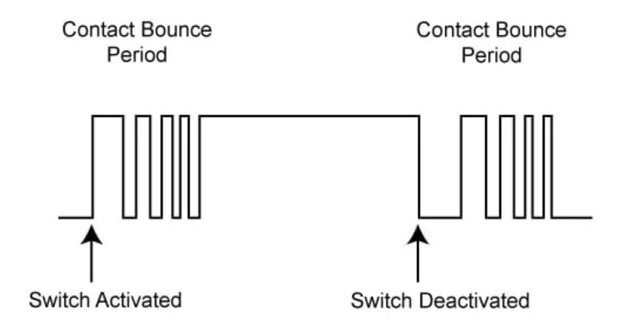

Figure 9 – Button Bounce for active high button

In our case, since the reset button is active-low and is used to reset the system, any unintended multiple transitions caused by bouncing could result in erratic or unintended resets. Similarly, when releasing the button, residual bouncing could result in the reset signal being incorrectly deactivated multiple times or too soon.

Debouncing Method: Using a Counter-Based Approach

To address the bouncing issue, we implemented a debouncing mechanism in the FPGA using a counter-based approach.
This ensures that the reset signal is only recognized as valid when it has been stable for a sufficient number of clock cycles.

Methodology:

1. Signal Stability Verification with a Counter
- The signal from the physical button (KEY0) is sampled on every clock cycle.
- A counter tracks how long the button signal remains unchanged.
- If the signal remains stable for a predefined number of clock cycles (e.g., corresponding to 10ms), it is considered valid.
- If the signal fluctuates before reaching the required duration, the counter resets, ensuring only a stable input is processed.

2. Stable Reset Activation and Deactivation
- When the button remains pressed (logical 0) for the full duration of the counter, the system recognizes a valid reset signal.
- When the button remains released (logical 1) for the full duration, the system registers that the reset has been deactivated.
- Any rapid fluctuations caused by bouncing are ignored, as only a signal that maintains stability over multiple clock cycles is considered valid.

How This Solves the Problem?
This debouncing method ensures:
Stable Reset Activation:
- The reset is activated only when the button has been consistently pressed (logical 0) for the required duration.
- This prevents false resets caused by transient bouncing during a press.
Stable Reset Deactivation:
- The reset is deactivated only when the button has been consistently released (logical 1) for the required duration.
- This prevents unintended state transitions caused by bouncing during release.
Noise Filtering:
- Any rapid fluctuations in the button signal due to mechanical bouncing are ignored.
- The counter ensures that only a signal that remains stable over multiple clock cycles is processed.

Post silicone

Hardware Setup for Post-Silicon Validation
To support smooth integration of the fabricated chip on the PCB, the design uses the QFP (Quad Flat Package) form factor. This package was selected due to its mechanical robustness, accessibility, and compatibility with standard surface-mount assembly processes. The QFP offers leads on all four sides of the package, which simplifies routing of I/O signals and power rails across multiple directions on the board.
The selected variant includes 44 leads with a 0.8 mm pitch, ensuring sufficient pin count for our data bus, control signals, and power interfaces, while maintaining a compact physical footprint. The exposed pad and grounded leads also help improve thermal performance and electrical stability during high-speed signal operation.
This packaging choice provides a practical balance between integration density and testability, making it well-suited for the post-silicon validation stage, where direct access to all signal lines is essential.
Figure 10 – Top package Pin Placement

Pin Placement

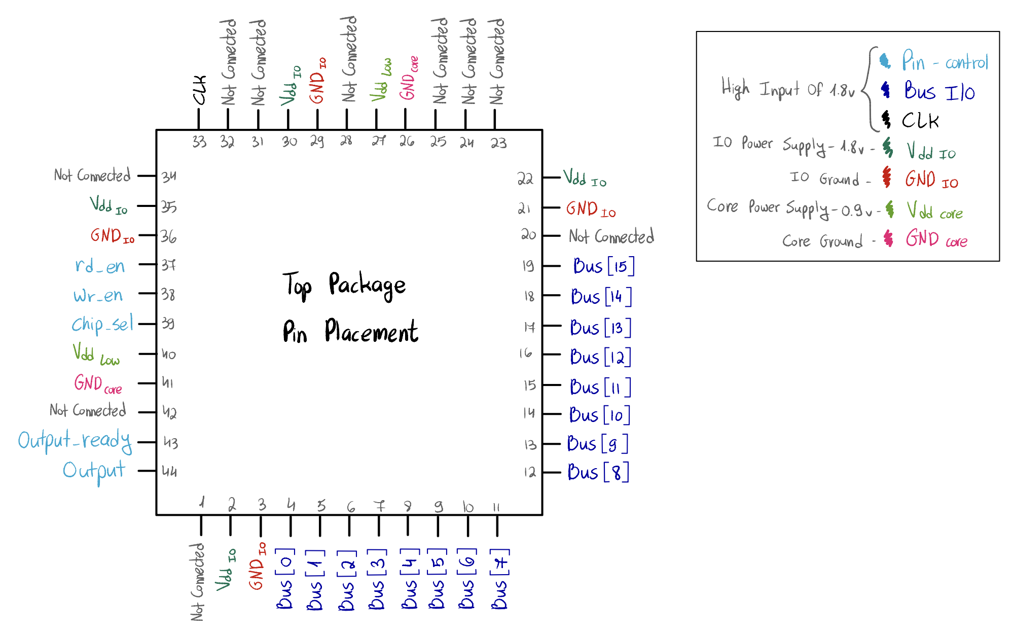
The diagram below shows the final planned pin placement for the DUT

Pinout Description
- Data I/O Bus signals (Bus[0] to Bus[15]) are placed consecutively along the bottom and right sides of the package to allow for compact and uniform routing of the 16-bit bus.
- Control signals such as rd_en, wr_en, chip_sel, output_ready, and output are grouped on the left side to ensure clean timing alignment and simplified interface with the FPGA.
- The clock input (clk) is located at the top-left corner, isolated from data lines to minimize signal interference and jitter.
- Power domains are clearly separated for electrical stability:
  - VDD_IO (1.8V) and GND_IO provide power and ground for the I/O interface.
  - VDD_core (0.9V) and GND_core supply the internal logic of the chip.
- Several pins are intentionally marked as Not Connected, allowing layout flexibility and future expansion if needed.
This pin configuration was chosen to support clear signal organization, good power integrity, and ease of integration with the FPGA board and level shifter. It reflects the final layout constraints while preserving accessibility for debugging and measurement during post-silicon validation.

System-Level Schematic: DUT Integration and Power Routing

As part of the preparations for the post-silicon validation phase, that will take place next year, we created a schematic that illustrates the expected physical integration of the fabricated chip on the test board. This schematic serves as a clear communication tool between the FPGA validation team and the chip design team, showing how signals and supply voltages are routed to the DUT. The focus is on representing the signal flow and power delivery rather than detailed pin-level schematics.

The following figure presents a system-level schematic that outlines the physical wiring and voltage domains surrounding the DUT during post-silicon operation. It highlight component placement, power sourcing, and data path routing between the DUT, level shifters, and the external control interface.

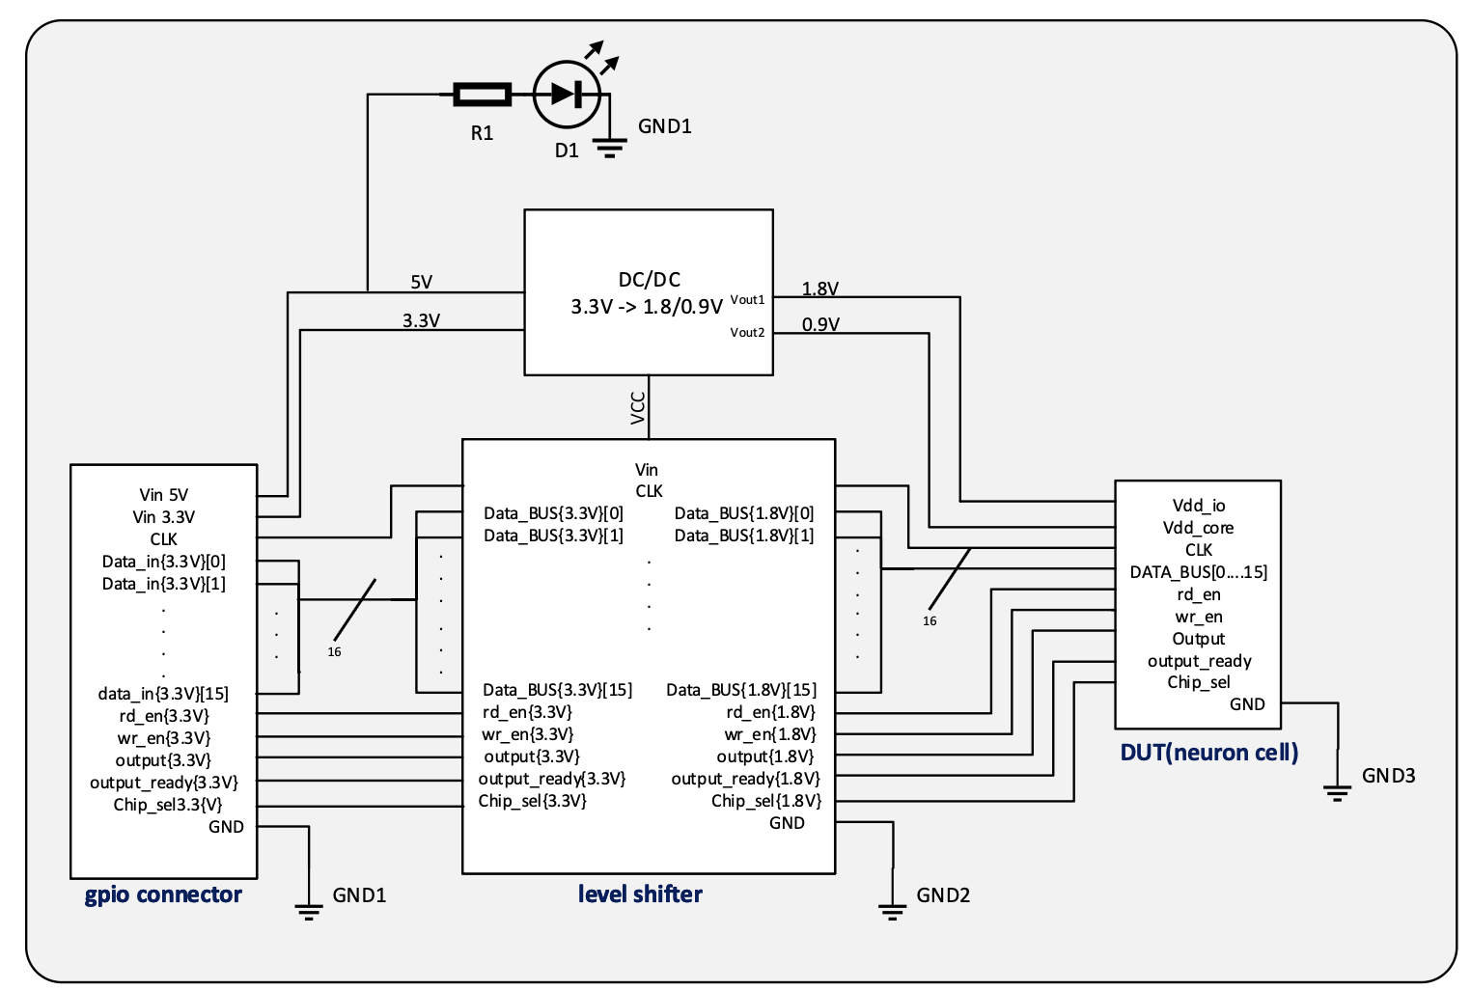
On the right side of the system is the DUT, which operates with two separate power domains: 1.8V (Vdd_io) for the I/O interface, and 0.9V (Vdd_core) for internal logic. The DUT receives a 16-bit wide Data_BUS, a CLK signal, and several control inputs including rd_en, wr_en, and chip_sel. It also provides output signals such as output and output_ready.
Figure 11 – Dut integration and Power Routing
A level shifter, located at the center of the diagram, converts signals from the 3.3V logic domain (used by the FPGA and GPIO interface) down to the appropriate levels required by the DUT - 1.8V for I/O and 0.9V where necessary for internal logic interfacing. All bidirectional or output signals from the DUT also pass back through the level shifter to be compatible with the FPGA's 3.3V domain.
The DC/DC converter receives a 3.3V input and supplies two output rails: 1.8V for the DUT's I/O domain and 0.9V for the core logic. These are distributed to both the DUT and the level shifter.
On the left side, the GPIO connector serves as the interface with the FPGA. It delivers all incoming control signals, clock, and data lines at 3.3V logic level. These signals are routed through the level shifter to ensure compatibility with the lower-voltage DUT.

Appendix

Tasks to Be Completed-
- Define and implement a method for testing specific edge cases that cannot be generated using the existing Python-based input generator. Includes internal state-driven behaviors, test sequences that require precise timing, conditional logic, and patterns that go beyond static input matrices.

Unknown yet-
- The exact clock frequency of the chip is currently unknown and will be provided by the chip team in the future.

